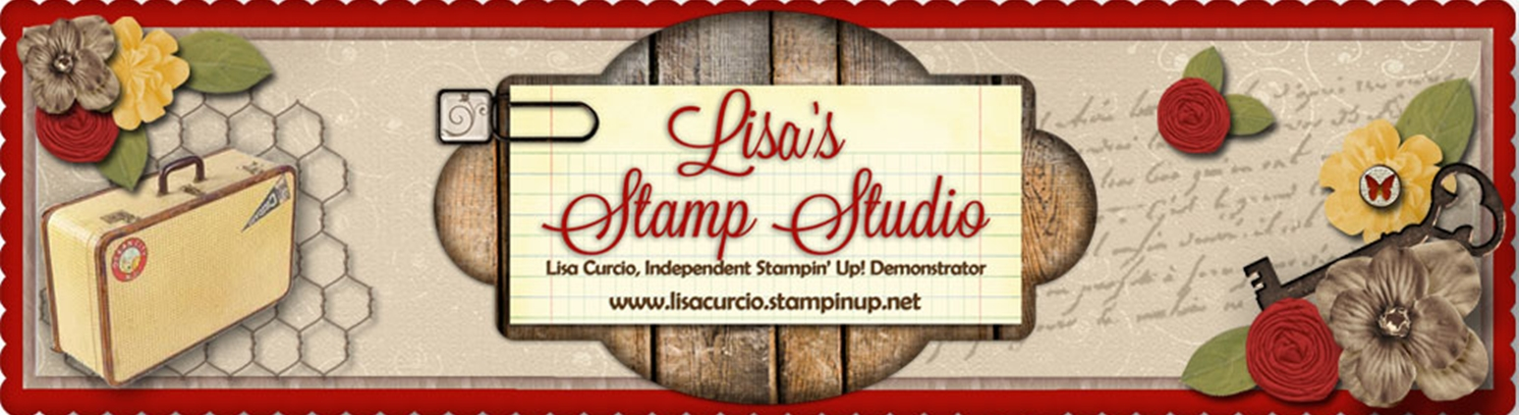
Lisa’s Stamp Studio
www.lisasstampstudio.com

Sunburst Sayings Bundle Card
All images © 1990-2016 Stampin’ Up!®
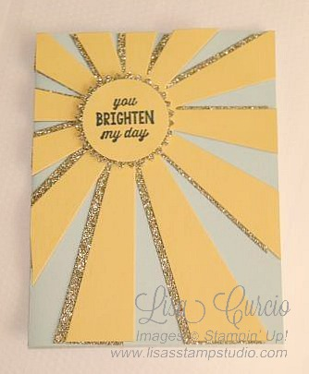

Supplies:
- Stamp Sets: Sunburst Sayings (140722w, 140725c); *Sunburst Sayings Bundle (140808w, 140807c)
- Inks: Memento Tuxedo Black Ink (132708)
- Paper: Pool Party Cardstock (122924); Daffodil Delight Cardstock (119683); Gold Glimmer Paper (133719)
- Other: Big Shot (113439), Magnetic Platform (130658), Sunburst Thinlits Dies (140617*), 1-3/4” Scallop Circle Punch (119854); 1-3/8” Circle Punch (119860); Mini Glue Dots (103683); Dimensionals (104430)

Measurements:
- Pool Party cardstock: 5 ½” x 8 ½”, score at 4 ¼”
- Daffodil Delight cardstock: 5” x 6-1/2”; 2” x 2”
- Gold Glimmer Paper: 5” x 6-1/2”; 2” x 2”

Instructions:
- Fold Pool Party cardstock on score line to form card base.
- Run Daffodil Delight cardstock and Gold Glimmer Paper through Big Shot using Magnetic Platform and Sunburst Thinlit die.
- Adhere two die cut pieces together using Mini Glue Dots, turning slightly to offset Gold Glimmer die cut behind Daffodil Delight die cut.
- Add die cut unit to card front, trim off excess/overhang.
- Punch Gold Glimmer paper using 1-3/4” Scallop Circle punch. Re-punch turning scallops to create ‘points’. Add to ‘sunburst’ center using Dimensionals
- Punch Daffodil Delight cardstock using 1-3/8” Circle Punch. Stamp ‘sentiment’ using Memento Tuxedo Black ink. Add to card front using Dimensionals.

