**Party with Cake Cookie Favor**

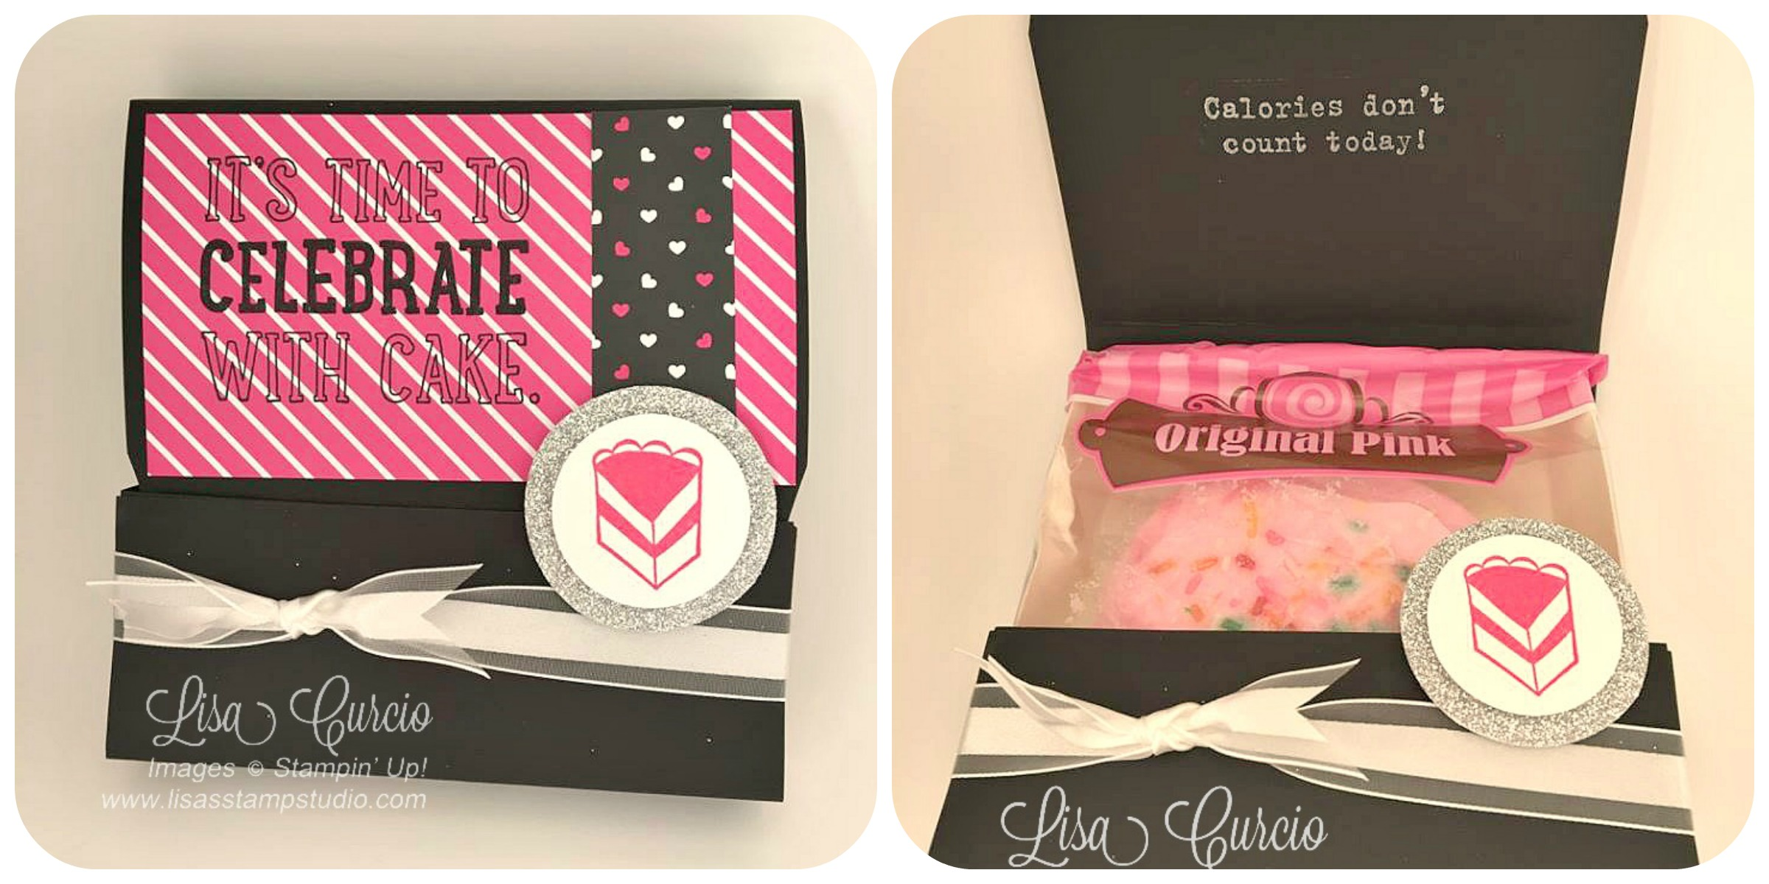

All images © 1990-2016 Stampin’ Up!®

**Supplies**:

* **Stamp Sets *–*** Party with Cake(wood 140669 or clear 140672)
* **Cardstock** – Basic Black 12x12 (124267); Whisper White (100730)
* **Stamp Pads** – Archival Basic Black (140931); White Craft Ink (101731), Melon Mambo (126948)
* **Misc**. – Pop of Pink Specialty Designer Series Paper (141648); 5/8” Organza Ribbon (114319); Silver Glimmer Paper (135314); Dimensionals (104430); 1-3/8” circle punch (119860); 1-3/4” Circle Punch (119850); Stampin’ Trimmer (126889) or Simply Scored (122334); Tear & Tape adhesive (138995), Granny B Pink Sugar Cookie

**Measurements**:

* Black cardstock: Holder: 12’ x 5” (scored at 2”, 3”, 7-3/4” and 8-3/4”)

Black cardstock: Band 12” x 1” *(scored at 2-1/2”, 3-1/2”, 8-1/2” and 9-1/2”)*

* Pop of Pink designer paper (striped pattern): 4-3/4” x 2-3/4”
* Contrasting designer paper of your choice: 1” x 2-3/4”
* Scrap white cardstock
* Scrap glimmer paper
* 17” of ribbon

**Instructions:**

1. 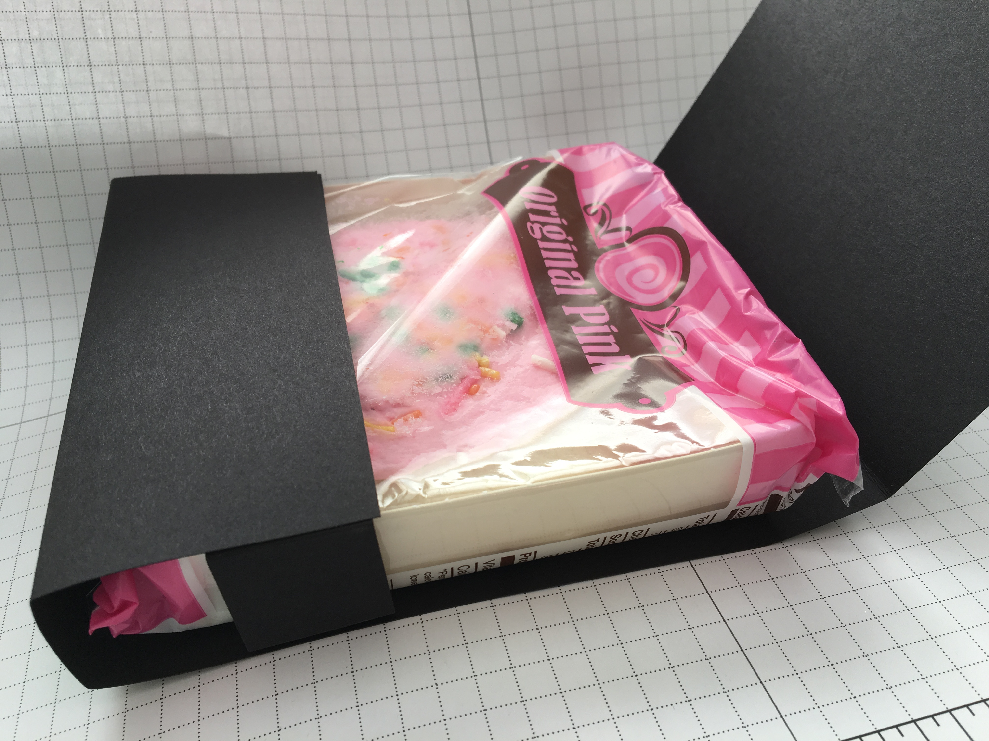Stamp greeting on the right side of designer paper using black ink. Adhere contrasting designer paper strip to right side.
2. Punch Glimmer Paper using the 1 ¾” Circle Punch.
3. Stamp the cake image in Melon Mambo ink on white scrap cardstock. Punch out with 1-3/8” circle punch. Attach to Glimmer Paper with Dimensional.
4. Fold on score lines. Attach black cardstock band to the inside front edge using Tear & Tape (meeting the ends in front) and to inside back of card so the cookie slides in as shown:
5. Adhere pink designer paper to the top of the favor.
6. Tie the ribbon around bottom half of the favor.
7. Attach Glimmer Paper circle to the bottom half of card using Dimensionals. Tuck the top flap into bottom of favor. The circle image will help keep the favor closed.