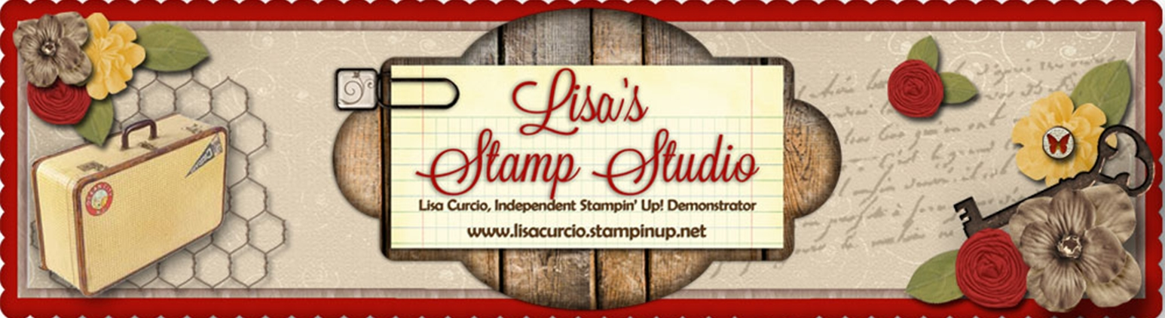
Lisa Curcio
www.lisasstampstudio.com

Swirly Celebrate Card
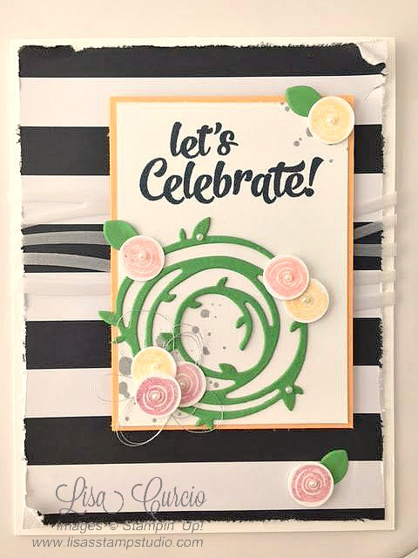

All images © 1990-2016 Stampin’ Up!®

Supplies:
- Stamp Sets – Swirly Bird (141749); Confetti Celebration (142034)
- Cardstock – Peekaboo Peach (141417); Cucumber Crush (138335); Whisper White Thick (140272); Cardstock Vellum (101856)
- Stamp Pads – Smoky Slate (131179); Memento Black (132708); Peekaboo Peach (141398); Flirty Flamingo (141397); Sweet Sugarplum (141395)
- Misc. – Pop of Pink (DSP) (141648); Swirly Scribbles Thinlits Dies (141497); Basic Pearls (119247); Dimensionals (104430); ½” Circle Punch (119869); Silver Thread (138402); Multipurpose Liquid Glue (110755); Glue Dots (103683); Snail (104332)

Measurements:
- Whisper White Thick- 4 ¼” x 11”
- Peekaboo Peach- 3 5/8” x 2 5/8”
- Whisper White- 3 ½” x 2 ½” + scraps for flowers
- Cucumber Crush- approx. 3” x 3 ¼”
- Cardstock Vellum- 2” x 6”
- DSP: Pop of Pink- 5 ¼” x 4”

Instructions:
- Fold white cardstock base in half.
- Distress the edges of the DSP by carefully dragging the edge of your scissors along the edge of the paper. The paper will fray, possibly event rip a little. This adds to the distressed look. Adhere to the white card base.
- Die cut the wavy lines using Vellum cardstock.
- Adhere to the center of the designer paper. NOTE: Add adhesive only where the top layer will hide it.
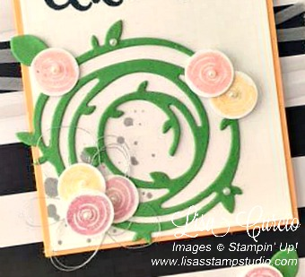
- Die cut a swirly flower and 3 leaves from Cucumber Crush cardstock.
- Stamp the small flower image on white cardstock scraps using Sweet Sugarplum, Flirty Flamingo and Peekaboo Peach ink pads. I stamped off on a few to get a lighter shade of the same flower. Punch flowers using ½” circle punch.
- Stamp splatter image in Smoky Slate ink.
- Stamp the sentiment in Memento ink on the white cardstock layer. Adhere the white stamped layer to the Peekaboo Peach cardstock. Adhere the layer to the front of the designer paper using Dimensionals.
- Adhere the swirly flower using liquid glue sparingly.
- Create a ‘messy nest’ of silver thread and adhere with a Dimensional. Add a flower to the top.
- Add the remaining flowers using a combination of Dimensionals and Glue Dots for different heights.
- Add leaves to flowers using Glue Dots.
- Add pearls on flowers and cardstock as desired.

